**Game Ideas**

**Membrance**

Weekly Meeting: Thur 4pm

Zoom Link: <https://nus-sg.zoom.us/j/89543665819?pwd=S2U4V2NtSU14ZFlFWHg3RC9rdEFOUT09>

Roles/Responsibilities:

Milestone 1:

* Story plot/theme and character setting
* GUI
  + Different indicators
* Aesthetics - Art, music, sound effects (can decide after actions)
* Level design
  + Theme
  + Assets
  + objects
* Physics
  + Environment objects
* Basic actions
  + Walking, dash/dodge, block, etc
  + Can have basic enemy to test basic actions

Milestone 2:

* Strategic actions
  + Abilities
  + Attack damage numbers (how much of enemies’ health)
* Level design
  + Puzzles
  + Location of enemy
* Enemy design & AI
  + Balancing

Theme/Direction: Perception, duality, overcoming, accepting, conflicting, hope, balance, wonder

Setting: Idealized imaginary world, slowly become corrupted

(Presentation: 15-20 slides)

Slides Breakdown

1. Introduction: High-level summary
   1. Genre
   2. Platform
2. Story
3. Goal & main characters
4. Flow of the game

1) Title Section:

* This section should include, name of the game, game genre, platform, and team size and members names.
* Codename: Adverlocity

**Name of the game:**

1. Membrance
2. Memsorption
3. Maybe a single word that can represent/partially represent theme of our game and then makes the player ponder what our game is about? - e.g. Memories, Remember, Reminiscence
4. Collector/Battle of Memories, Perplexed memories, The gallery pf memory, Pandora’s box of memories

Game genre: Action Platformer

Platform: PC

Team size: 6

Members: ALEX TEO KANG JIE, CUNG CHAN THANG, EDELINE TENGES, JASON TAY, TIAN FANG, ZHU BO

2) Summary Section (max: 1 page):

* You should present a high level description of the theme, goal of the game, the main characters, the flow of the game, what makes the game unique (use the LENSes to describe), key selling/marketing points and the primary actions the player takes.

Question: are we still including memory loss/gain? May or may not, depending on the story flow

**High-level Description**: <insert game name> is an action-platform game which centers around <protagonist name>’s contradictory journey of finding truth in a world filled with his past traumas in monster form, while losing parts of himself along the way.

**Background Description**: Our protagonist is setting out to defeat the demon king/overlord/big bad. Along the way in his travels, the world starts to unravel. The protagonists starts to sense that something is not right with them themselves. Reality is breaking down, the world itself begins cracking open. Monsters become overlaid or superimposed with things that are more common with our world than the actual setting. Only you can see these disfigured beings.What exactly is the world and its truth? Is this truly reality?

The bosses, as we go further along also begin to take on what could be called the player’s past traumas in reality. The final boss, becomes a heavily amalgamated version of all the traumas.

When we defeat it, depending on the completion of certain objectives along the way could see us facing a dark, heavily corrupted version of ourselves, with abilities similar to what we have gained along the way, but enhanced by the earlier traumas’ abilities. The ending would depend on these bosses. If we only defeat the main final boss (demon king), we could wake up, to the truth in the real world, but still broken on the inside. If we “defeat” the secret boss (self), we wake up as a better person.

Whatever reality is still undecided.

—---

You are the hero of the Grand Kingdom, with the sacred duty of defeating the Demon King

Traverse the various world in levels, defeat enemies to grow stronger to defeat the Demon King!

**Goal**:

Player needs to successfully reach the end destination each level, by traversing the “world” and defeating opponents. Finding different things(collectibles, memories, etc?)

– From the story, similar to Souls games – Fight bosses and find the story on your own? Also have environmental story telling

**Main characters**:

* Protagonist
* Enemies & boss
  + E.g. Bullies/Enemies/People you don't get along with
    - Strategy: Not attack them directly — attack the little monsters chaining them back (representing bullies' own insecurities and trauma)
    - If you attack them directly, the little monsters grow/increase health
    - Moral: understand people's stories and help them, instead of just clashing with them

**Primary Actions (Lens of actions):**

1. Basic actions:
   1. Move
   2. Jump
   3. Climb? (ladders/stairs)
   4. Collect items (collision collects)
   5. Dash
   6. (Main/base combat) - Slashing with a melee weapon
   7. (more to be added)
2. Strategic actions:
   1. Absorbing enemies' power and using it to attack them
      1. Add enchantment to the main weapon
      2. Time freeze/slow down time
   2. Use objects & elements from surroundings to defeat enemies

**Flow**: (general):

1. Main goal (aforementioned)
2. Linear level arrangement
3. Ending: The bosses, as we go further along also begin to take on what could be called the player’s past traumas in reality. The final boss, becomes a heavily amalgamated version of all the traumas. When we defeat it, depending on the completion of certain objectives along the way could see us facing a dark, heavily corrupted version of ourselves, with abilities similar to what we have gained along the way, but enhanced by the earlier traumas’ abilities. The ending would depend on these bosses. If we only defeat the main final boss, we could wake up, to the truth in the real world, but still broken on the inside. If we “defeat” the secret boss, we wake up as a better person.
   1. Can have different ways to defeat the boss: e.g. using iconic absorbing ability

**Flow**: (per level)

1. The player starts at the beginning of the level
2. Upon encounter with enemies that are spread throughout the level, the player can use any of the mechanism mentioned later:
   1. The player will sometimes find blocked paths, and will have to figure out the mechanism to unlock it
3. The player collects items (e.g. shards of memories, food to recover health, coins, etc) along the way if found
4. Upon reaching the end destination successfully, player will learn more of the story progression and can move on to the next level

**Unique point (use the LENSes to describe)**:

[Note: Connect story with mechanic]

* Lens of meaningful choices/triangularity (39,40) : [Risk vs reward] Unlock ___ (Tian Fang)
  + Cost:
    - Reduce health
    - Currency: Sanity points/gems
    - Weapon-specific
    - Controllable levels: Max sanity loss
      * Below certain thresholds: Platforms disappear, enemies get tougher
    - Tied to the story - e.g. use it at the risk of some memories (with family,friends etc) will be lost forever
    - Sanity gauge decreasing - level becomes harder, more collectibles?
  + Reward:
    - special weapons
    - Abilities（power up, rage mode etc）
* Lens 6: Problem Solving
  + Players have multiple ways to defeat opponents
  + Technique/skills v.s. Strahtegy?
* Lens 58: The Puzzle
  + Some interesting yet manageable puzzle that will require the player to think a bit to solve it
* Lens 7: Elemental Tetrad
  + Mechanics
    - Action mechanism:
      * We can copy <https://www.yachtclubgames.com/games/shovel-knight-shovel-of-hope> and bind our character to **1 main weapon that sets the theme**. Shovel knight used a shovel, so maybe our **psycho maniac** can be a menace slashing with a machete/raw fist → Main combat = slashing/punching. Check out all their 2D platformers here: <https://www.yachtclubgames.com/games/shovel-knight-treasure-trove> Each series have 1 main weapon that is very faithful to the main character. So we can design the combat to **illustrate that our main character is a maniac**
    - **Character switching**: (This may ruin our story)
      * ~~I was thinking~~ [~~https://store.steampowered.com/app/838310/Bloodstained_Curse_of_the_Moon/~~](https://store.steampowered.com/app/838310/Bloodstained_Curse_of_the_Moon/) ~~style, you can switch between main characters that can do different stuff, but idk what they think about it, so at certain puzzles/enemies you have to switch to the correct character (assuming 2D platformer)~~
      * ~~Characters become more crazy~~
    - **Equipping abilities/weapons** on the player itself
      * Switch immediately
      * Inventory management
      * Upgrading weapon with more abilities rather than switching weapons?
    - **Adding pets/magical creatures**
      * Creature can be responsible for absorbing & storing all the skills
  + Story
    - aforementioned
  + Aesthetic
    - Progressively growing darker (Note: we should have some level/room/space to release the tension)
  + Technology
    - UE engine
    - PC Windows 10 support
* Lens 91: Character Transformation Alex
  + The character gains back precious memories (both good and bad) as the player is completing the game?
  + The character cherishes good memories more and learns to appreciate bad memories (those that help the character grow?)
  + Character confronts his past, empathises, reflects on said trauma to an extent

**Selling/Marketing points**:

—-----------------------

**Alex:**

*Types: First Person (FP)Shooter/ Hide and Seek/ Platformer/ Open World Exploration*

*Third Person SHooter/ Platformer/Open world*

*2D platformer/ shooter*

*Top down Strategy/ social deduction*

*Rhythm*

*Story: Deep storyline/ environmental story telling?/ no story*

*Idea 1: Some kind of 1st person horror exploration game with platforming?*

*1st level starts with normal exploration, either fall to traps or could be chased*

*Levels going forward will have some kind of platforming*

*Story: Either amnesiac route, or fell into a trap and now trying to find a way out*

*Final level becomes some sort of open world with platforming trying to find the exit, but also can look around to find out more about domain*

Protagonist (first/third person) → RISK vs REWARD

* Everytime they use weapon → lose health (permanently) → there should be ways to increase it back (resonate with theme of story if possible e.g. memories → cannot proceed with certain branches of the story, sanity)
* Aim: instead of always using weapon, they can use alternative tactics to escape/defeat enemy

Wake up, trying to find someone

* When you take more damage/use your weapon: question your memories
  + You start to not remember who you are → the future you is different
* Actually confronting past experiences
* Question:
  + Will you use your gun to clear your trauma away? → Erasing the bad things
  + If you use different methods → You are accepting and overcoming instead of avoiding
  + What situation would you use the gun?
* Main theme/aim: Make the player reflect

**Zhu Bo:**

Type:

First Person RPG game (probably single player), mainly story-telling (**LENS – Story, Emotion, Endogenous Value etc.**) with puzzle-solving/adventure components (**LENS – The Hero’s Journey**). Maybe can let players customize their own character avatar (**LENS – Control/Freedom + The Avartar**). Perhaps beside having a main storyline, can have side story/quest as well (e.g. free to move around to solve puzzles and fight monsters etc) (**LENS – The Pyramid**).

Inspired by Legend of Zelda and Genshin Impact, we can let the characters acquire elements (e.g. wind, earth, fire etc) and use these element skills to solve puzzles (**LENS – The Puzzle**), and to deal with monsters/villains (**LENS – Fantasy, Obstacles**). If we have sufficient time, we can try to add more customization like the day-night system, weather system, seasons etc.

Inspired by Pokemon and Monster Hunter, maybe there are ways to have pets/creatures to join in the team to help in solving puzzle/fight monsters and completing the story together? Can have treasure boxes that contains random items that can help out the character in the game (**LENS - Chance**).

Goal:

We can have a meaningful or interesting/unique theme to let the player experience the story as the character (try to achieve the **LENS – Essential Experience, Emotion, Fun, Surprise etc**).

Meaningful: environment, about family and friends, touching and heart-warming story, education purpose etc

Interesting/unique: horror, suspense/crime-solving, about remembering and traveling back childhood, time-travel to the future/past or a different world.

**Edeline:**

REFERENCE

* Past CS3247: <https://isteps.comp.nus.edu.sg/event/12th-steps/module/CS3247>
* this.place
  + <https://isteps.comp.nus.edu.sg/event/12th-steps/module/CS3247/project/4>
  + <https://www.youtube.com/watch?v=WkXQZ-q83Zo>

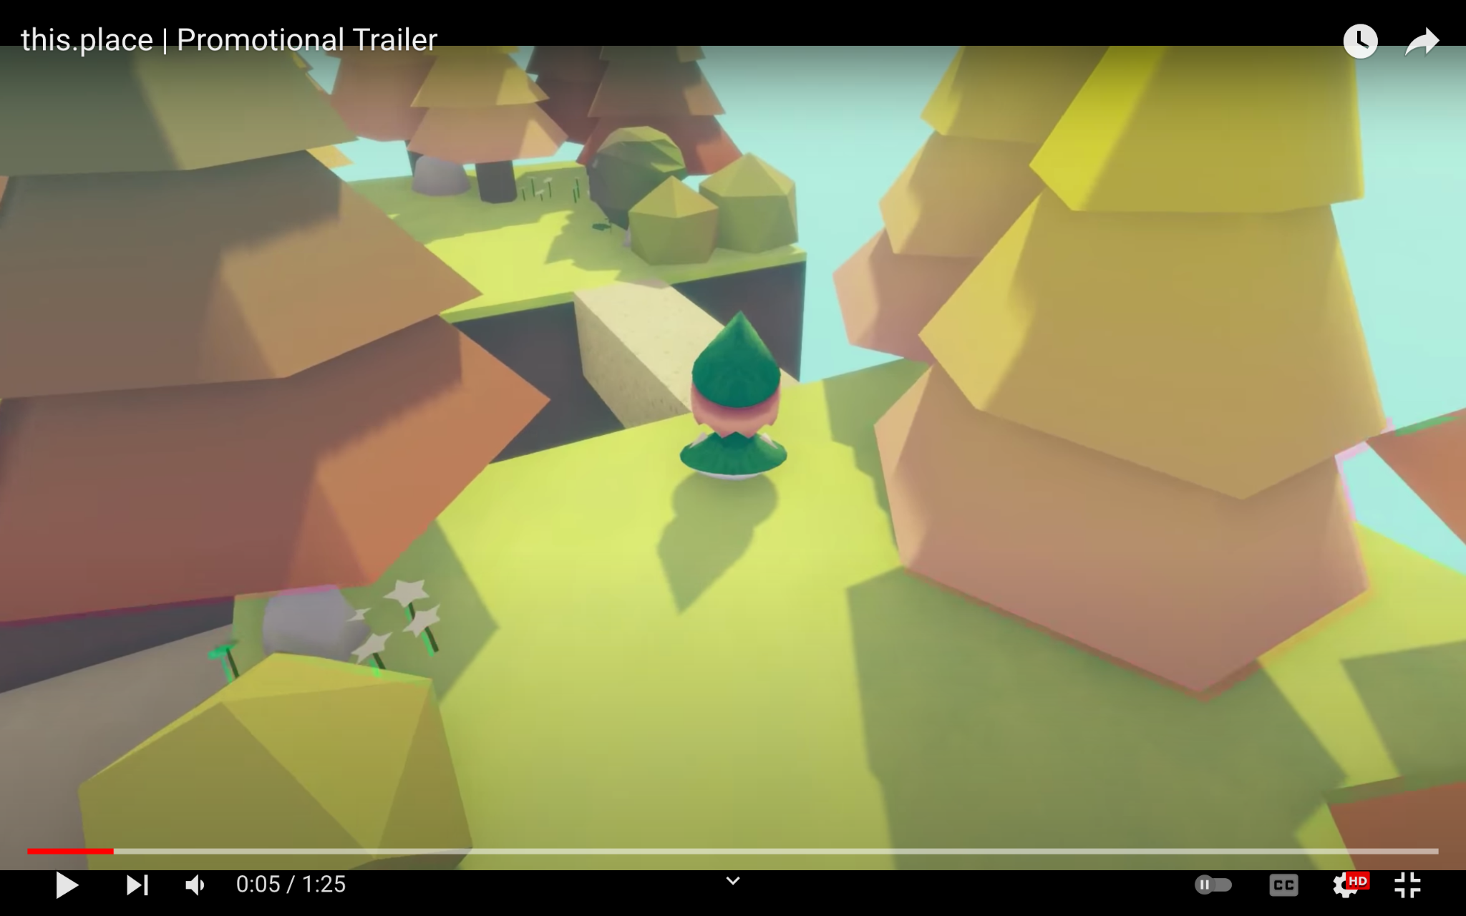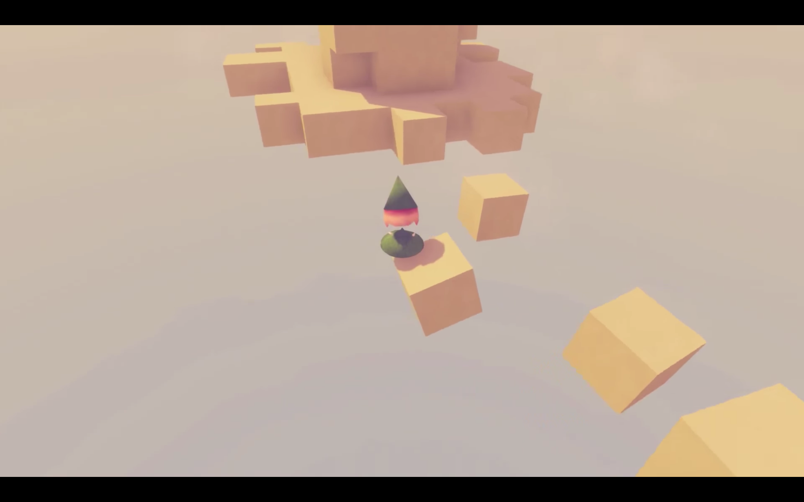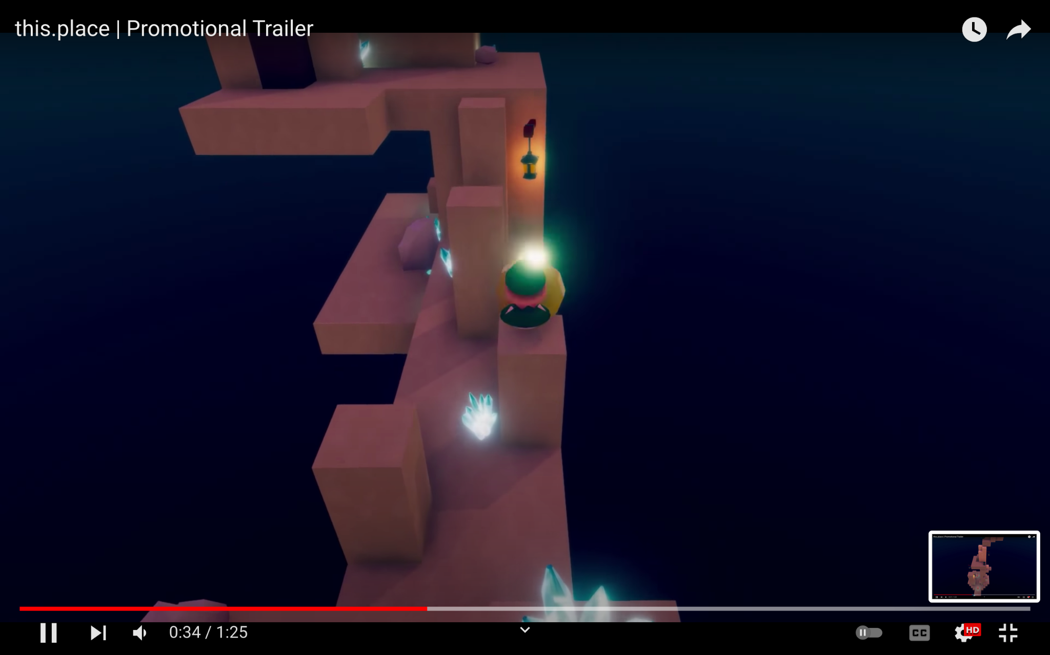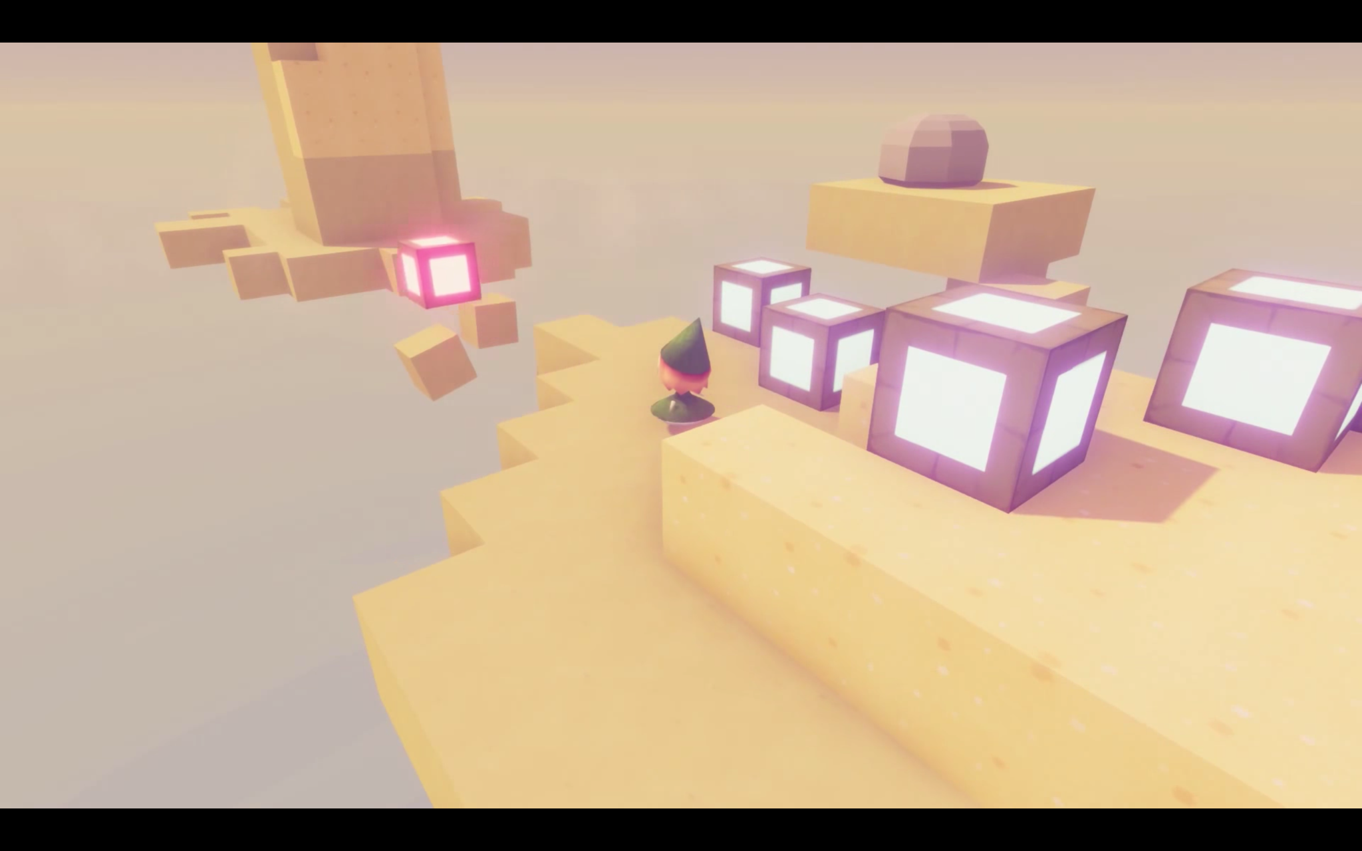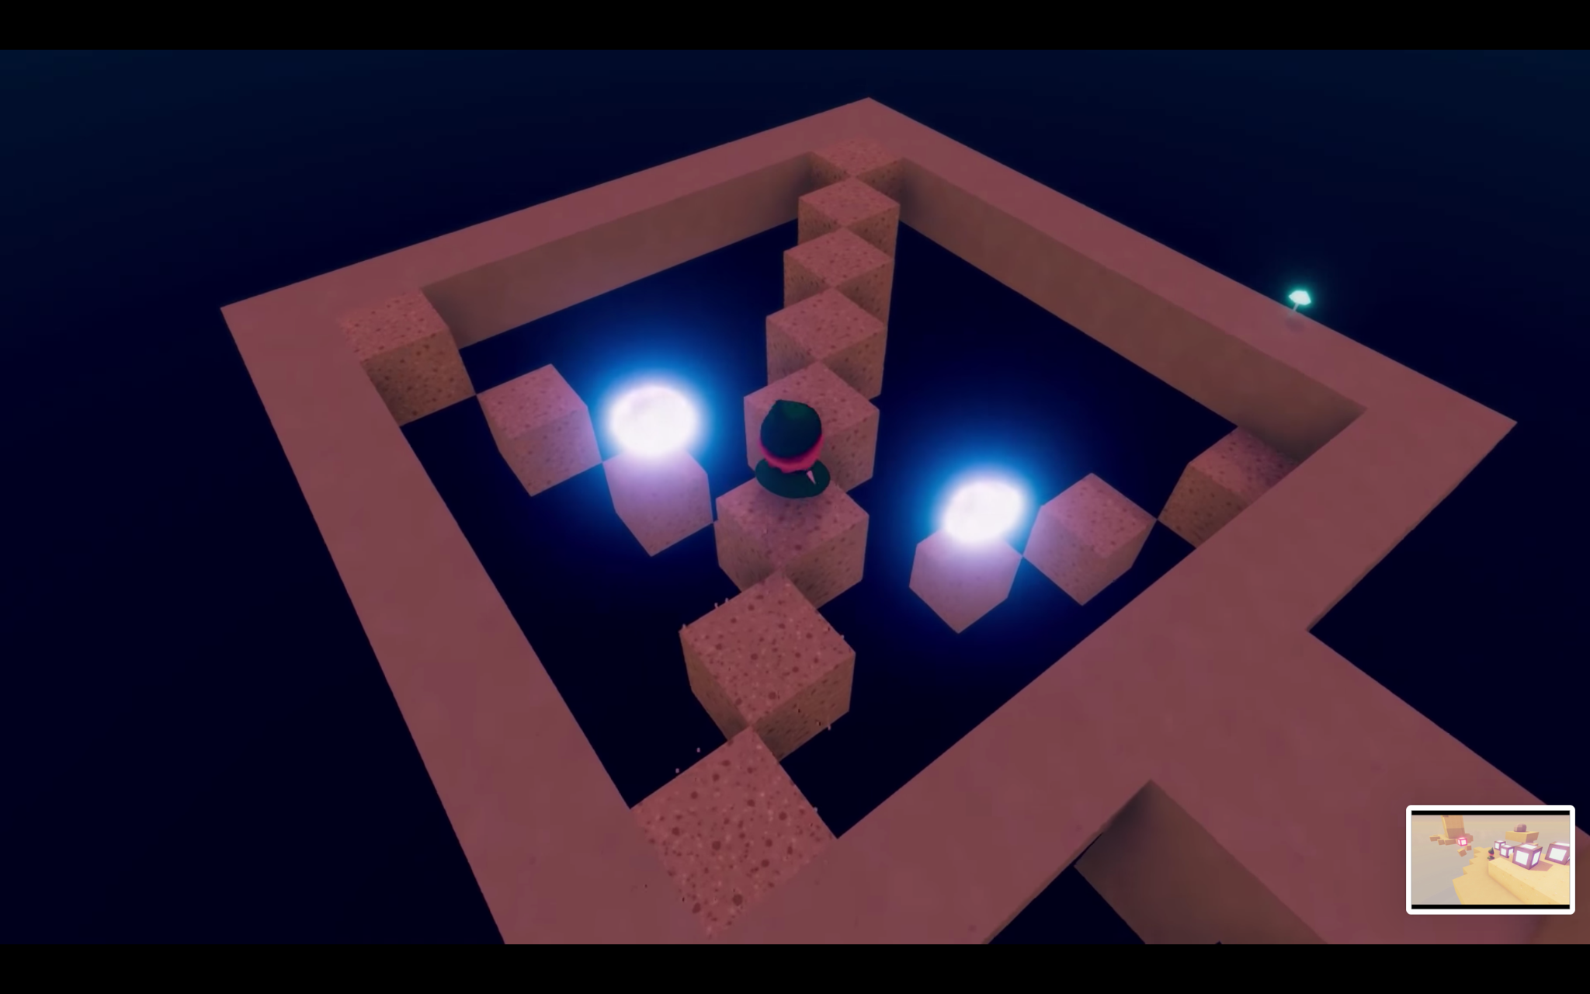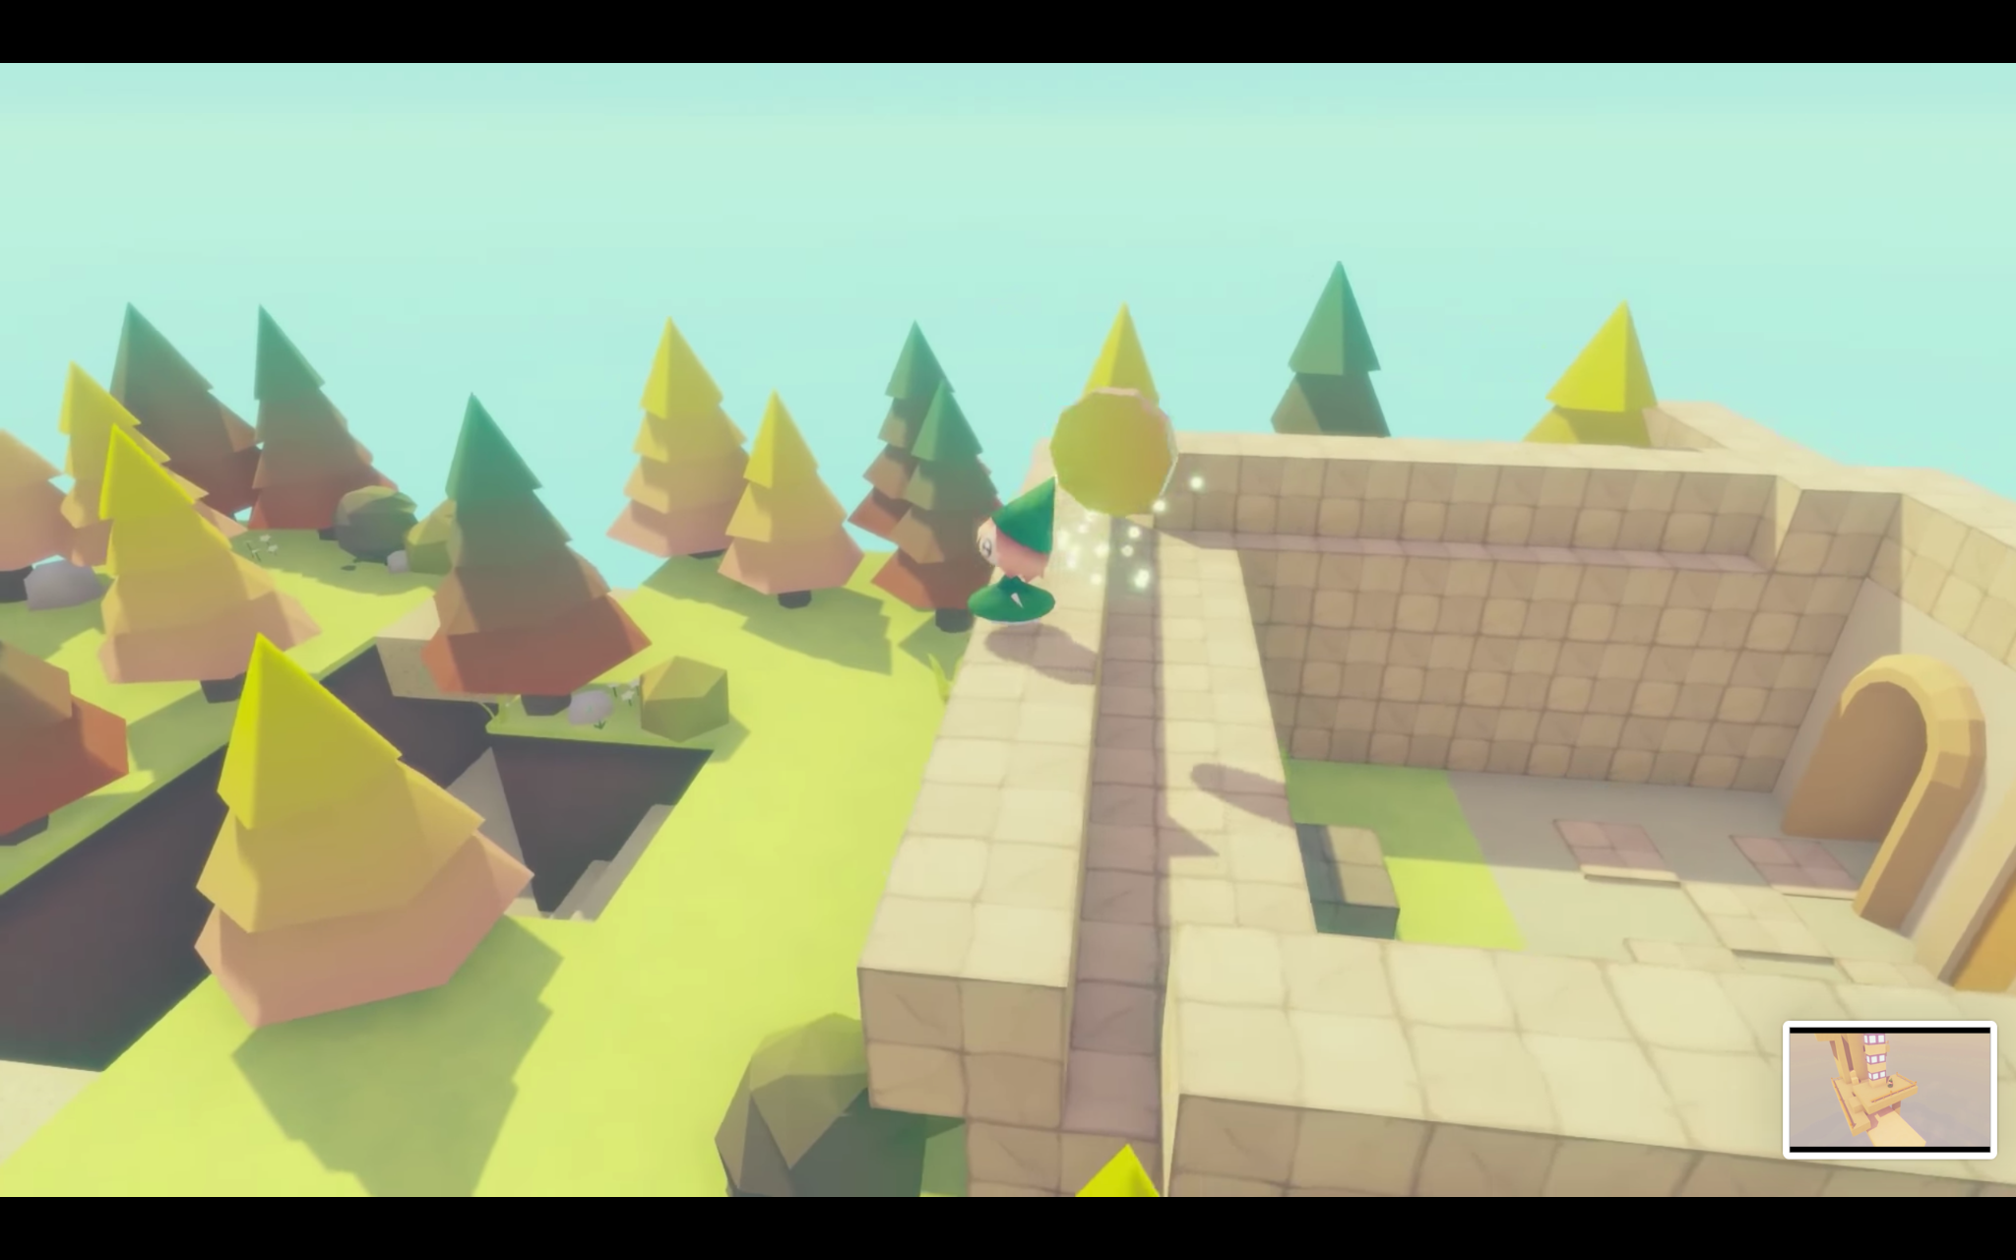

IDEA

**Core Concept/Mechanic**

* Puzzle platform game, reach a destination by overcoming obstacles
  + Activating a number of triggers to unlock the domain
  + Stories in between levels
* Complexity of development: we can adjust as we want accordingly (e.g. simplest form is just a platform game without the puzzles, can also adjust how long/complex each platform will be)

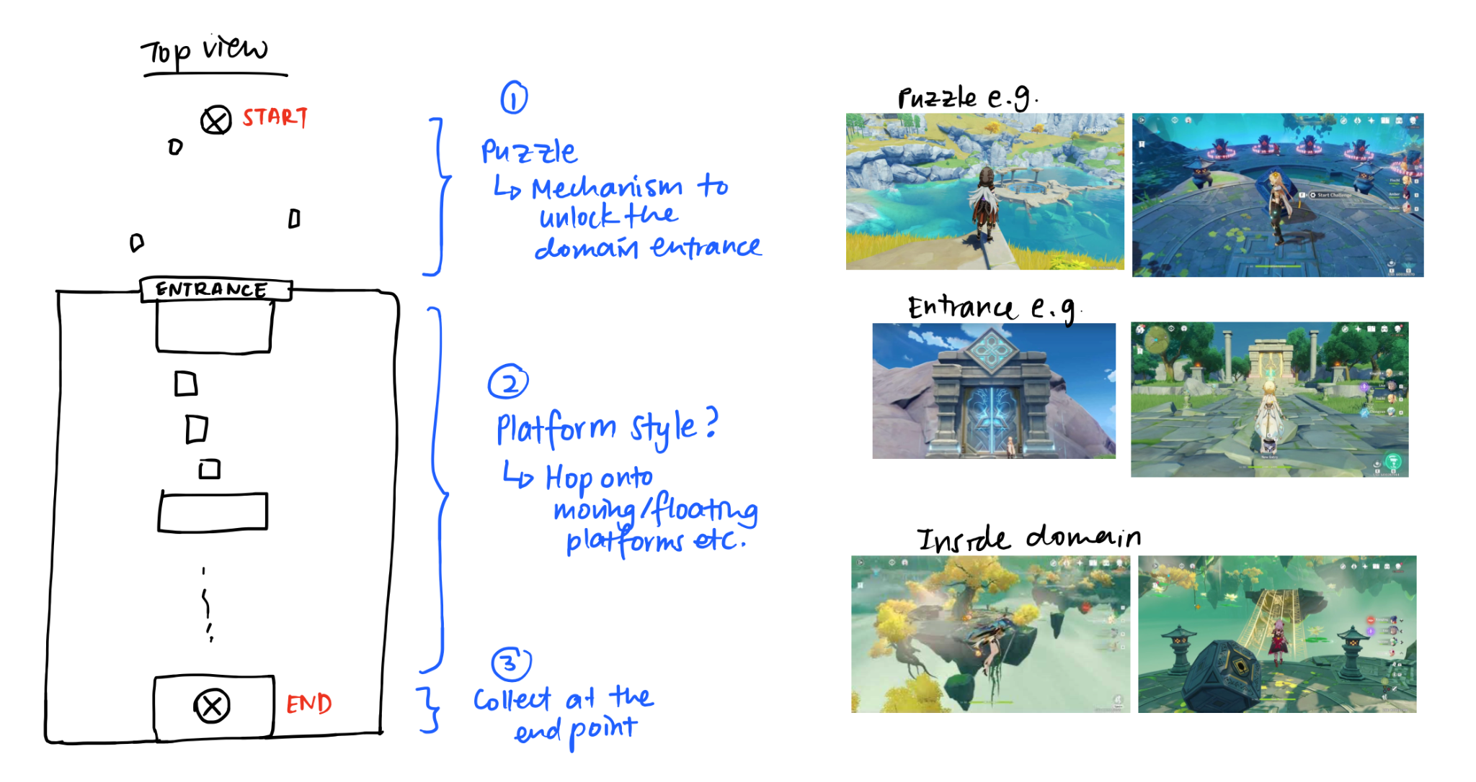

**Themes**

* **Theme 1**: Walking down memory lane — Childhood, teen, adult
  + Problem setting
    - Mischievous mage stole your memories, jumbled them up with fantasy elements to form puzzles & domains
  + Aim
    - Get your memory back bit by bit by successfully navigating through puzzles & domains, diving into your past (3 levels: Childhood, teen, adult)
  + Levels
    - Childhood: Finding your way home
      * playground elements mixed with weird fantasy clouds → the mind of the child
      * Many gaps and floaty areas
      * Ladders, slides, swings
    - Teen: Finding your way to your classroom
      * New obstacles: Stress & anxiety incarnate (but in a cute blob form)
      * Bullies in the form of monsters
    - Adult: ???
      * Colder, more one dimension
      * Can be pessimistic???

**Theme 1:** Possible additions

Plot: (But only used as an introduction to the game, so that the game itself won’t be too story-dependent.)

* Memory was actually filled with painful ones you didn't want to remember
* You were the one who asked the mage to remove your memories
* But the mage gave it back to you in the form of obstacles & puzzles to help you overcome and accept the painful memories (this will be the main theme for the rest of the game)

Obstacle: Stress & anxiety

* Walls/Blockers with special mechanism to unlock
  + Moral: you can't avoid stress, you must overcome them
* OR top & bottom boundary
  + Moral: must keep a balance

Obstacle: Bullies/Enemies/People you don't get along with

* Not attack them directly — attack the little monsters chaining them back (representing bullies' own insecurities and trauma)
* If you attack them directly, the little monsters grow/increase health
  + Moral: understand people's stories and help them, instead of just clashing with them
* After you defeat them, they become very weak e.g. baby
  + If you approach them gently

Suggestion

* 2 players split view
  + Interact with each other at some point
  + Overcome difficulties together
  + Childhood: remote connections
    - Encounter each other on vacation
  + Later on: meet each other again
* When they enter same level
  + Follow same rules but look completely different
  + Can see each other from across / Trying to meet in the middle
  + Only 1 person can see
* Tell the story from >1 person’s perspective
  + At the beginning, we don’t know the full picture
  + Play as each of the 13 people
* OR 2 different players cooperate
* **Theme 2**: Sky, land, sea in a fantasy land (journey/exploration to go back home, find something → put in obstacles along the way)
  + Problem setting / aim
    - Deliver something to the Ruler of the Sky, not sure what it is/what it’s for, find clues along the way → enter, get permission and pass domains of the Ruler of the Land and Ruler of the Sea
  + Levels
    - Sky: Floating platforms in the clouds
    - Land:
    - Sea: Submerged?
* Random ideas
  + Scissor paper stone operators/controls
    - Scissor: cut
    - Paper: Bridge/shield/stop/freeze
    - Stone: Weigh something down/attack
  + Rubik’s cube platform (playing field) that keeps turning

**Criteria**

* Not too dependent on a lot of graphics/very deep story
* Keep gameplay focused → not too many mechanics
  + Add new mechanic at the end

**Possible Combination**

* 3D platformer
* First person or third person → Can decide later, based on camera position

How many levels?

* Inclusive of tutorial level

Important factors

* Different ways to traverse
* Finding hidden items

Replay value?

* How well you finish the game (Mastery)
  + Shorter routes
  + Losing less lives
  + Better timing
* RNG
  + Hidden items are different
  + Power upgrades are different
* Add in different branches to the story
  + Different levels
    - Become harder/more pathways
    - Different aesthetics

Special mechanism

* How to lose memory?
  + Denote with a health/sanity bar
  + Lose your oldest memories first
* Reallocate health to something else
  + E.g. madness

Types of platformer games

* Action: Speed-based overcoming obstacles
  + Fighting monsters
  + Boss
* Puzzles: involve more thinking
  + → can just be the sugar on top, doesn’t have to be too crazy
* Finding your way
* Try not to die

What makes the game unique

* Eat the monster and get their power [Details to be discussed later on]
  + Fly to jump over a gap
  + Temporary
    - Active for only x amount of time
    - Absorption cooldown before the next monster??
  + Permanent
    - Save skills → only bring a few to each map?
    - (For balancing)
    - Maps that render some skills useless
* Character
  + The levels begin to break down towards the end
  + End: Are you sure you’re supposed to defeat the demon king?

RPGs

* We have to make a lot of monsters so that it’s not too repetitive
* Exploring around the area
* Different skills the player can equip

Ideas

* Giving players multiple ways to complete the game: brute force (somewhat complex battle mechanism like shield parry, dodge, abilities related to time freeze) vs clever way
* Time freeze (limited amount of time): plan your attacks, after time is up, attacks will happen (Katana ZERO)
  + E.g. move explosive from one place to another
  + Some operations that can only happen when you freeze time

–(comment from Thang): Maybe we can make this ability available from a tutorial boss xD to intro the whole ability absorption thing

* Like Zelda BOTW: have some unique abilities to utilize elements in the scene to defeat enemies more easily

Quest system? [In the later stage]

* Side quests that are not compulsory
  + Not NPC style
  + Can be pieces of paper, message from boss
* Objectives
  + E.g. collect certain item, meet certain enemy
* Motivation
  + Rewards

Question to TA:

1. 2D vs 3D platformer

**Thang:**

~~Theme:~~

~~FPS with "12" theme because many cool things come in twelves.~~

~~Each level has bosses of "12" theme, for e.g.~~

~~Level 1 we shootin' Zodiacs,~~

~~Level 2 we shootin' poker cards,~~

~~Level 3 we shootin' 12 mysteries of the world,~~

~~Level 4 we shootin' a dozen of types of eggs, etc.~~

~~Story:~~

~~Nineteen year-old male/female + 9-12 months doggo, u know twelve, "twoteen"~~

~~Goal:~~

~~Shoot the monster~~

~~Suggestion:~~

~~Mystery (e.g. world is obsessed with the number 12)~~

Game’s name and meaning/monologue behind:

* **Void Star:** Reflection of our protagonist, a bright, admirable star *(this reflects the fact that they are already heroes / achieved individuals in their field)* who is void of a clear identity *(there exists a* ***void*** *deep inside their <3)* traveling through the world in search for a better understanding of themselves. A cool interpretation of this title for legacy C/C++ people is the reference to void*, a pointer to void, reflecting our protagonist ability to possess anyone’s identity (or more exactly ability xD) and “become” them :D
* **Shoes:** Every story needs a hero and a villain, but every villain is a hero in their own mind. What does this make of men who condone the killing of villains for “the better”? To take away an egg from its mother and feed our own children, we became heroes to our family and villains to the poor defenseless bird.

This game tries to convey the message to the players: that it is easy for negative emotion to take over in the wrath of losing something precious, or being betrayed, or witnessing a horrible act. What’s difficult is the ability to not jump to conclusions, the ability to listen, understand, relate and sympathize; the ability to remind yourself before punishing another: *“you should never judge another man before you have walked a mile in his shoes.”*

(Originally this was titled **“2 sides”** to go with the idiom “there are always 2 sides to every story, but “**2 sides**” sound a bit weird. “**Coin**” was also considered for “there are always 2 side to the same coin” but this apparently meant something else)

* **Shell**: Confronting dark traumas and mental health issues is difficult, especially the amount of stigma around the topic in many cultures. The story of this game tries to convey that: Instead of thinking about the negative connotations or what others might think of you, you should be actively confronting these inner demons before it’s too late. You should be communicating, seeking help, and actively overcoming these fears that you are secretly running away from. Because choosing to avoid the problems is only a coping mechanism, a survival technique which before long, the traumas would have won the race and started to dictate the majority of your life and identity. Before long, while conforming to social norms to avoid meaningless judgment, you would have already lost that unique individualism, that self-worth, and become nothing more than a walking shell.

**Protagonist and Pet’s name**:

* Ywain and Simba (Reference to [Knight of the Lion](https://en.wikipedia.org/wiki/Yvain,_the_Knight_of_the_Lion) and well…Simba)
* Marcela and Argos (Reference to [one of the first woman to stand up for herself instead of just sitting there pretty in classics](https://en.wikipedia.org/wiki/Don_Quixote) and [Odysseus’s doggo, the only one to recognize him when he came back to his kingdom **in disguise**](https://mythworld.fandom.com/wiki/Argos_(dog)) after 20 years T_T)
* Aisenma and Tep (No reference D:)

1st idea is just me fantasizing knight of the lion.

2nd one has some meaning, since Marcela has that “non conforming to society” factor. Argos is just a good boi.

Last one just to have a 3rd idea, since I already suggested a male and female in 1st and 2nd. The hidden gem is how you spell the names backwards. “Amnesia and Pet”

**Initial Hook:** null, maybe we literally draw a hook at the splash art

**Jason:**

Co-op or single player play through levels in something like a dungeon with ~5 levels and each level has a boss fight. Players can find upgrades along the way, with the upgrades being random during each run

A game like fall guys/crab game where players play mini-games against each other.

* Settings are constrained
* Players can play all over again → not repetitive
  + Counter problem of repetitiveness with multiplayer

Benefit of multiplayer:

* Not necessarily need to have a story

Co-op (for the fun, don’t overwhelm)

* Number of enemies higher than single player
* Boss stronger
* Certain rooms: Need >1 player to activate

**Tian Fang:**

1. octopath traveler style pseudo 2D with gorgeous images (can possibly add in perspective changes while turning)

2. Position camera like Monument Valley (bird eye view). Platformer games

3. Mimic 2D games like Dead cells, hollow knights, Ori with different story and assets

4. Horror games with limited sight (less resource intensive)

**Feedbacks/Possible Concerns:**

* Art assets wise, especially since we are having a changing aesthetic
* Can be hard to tell such a deep story will simple assets
* How to make the game unique - selling points